# Introduction

This document provides step by step guidance for writing and running Python programs on a Windows machine that has Python installed. If your computer is not a Windows machine, or if Python has not been installed on it, please use the Learn On Demand Virtual Machine provided.

If you intend to work on a Python project and do not want to be constrained by the time limit on the Virtual Machine, Python can be installed from the following link:

[Download Python | Python.org](https://www.python.org/downloads/)

An online interpreter is available from Replit at the following link:

[Log In - Replit](https://replit.com/login)

It is free to sign up.

# Working Folder

You can put your working folder more or less anywhere but we recommend you put it under Documents. In File Explorer, right click on Documents, click on New and click on Folder.

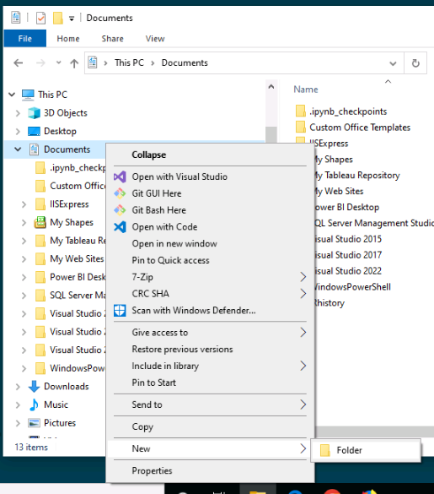

“New folder” appears in blue:

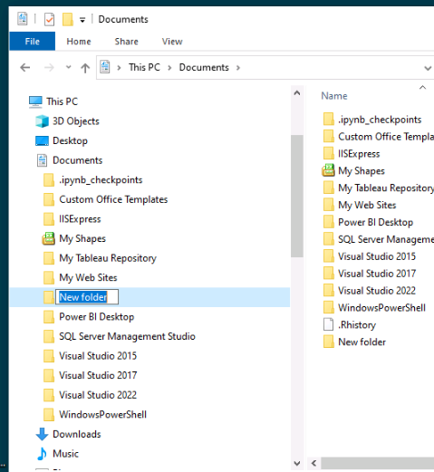

Type in a suitable name such as PythonArea. (You can include spaces but I generally avoid doing so when working with code.)

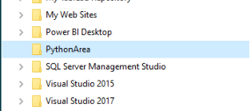

# Python File

There are several ways of creating a Python script file, but one of the quickest is to go into the folder, right click, select New, and select Text Document.

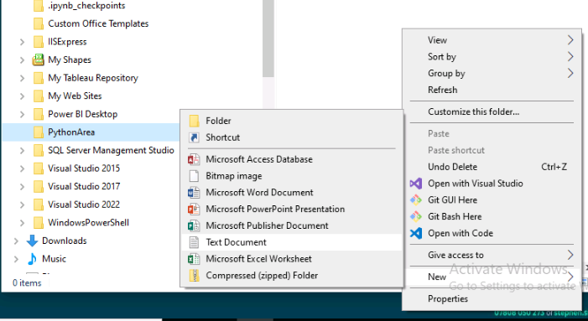

You should see a file called “New Text Document.txt” in your folder.

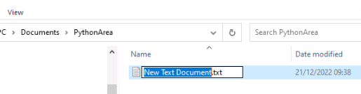

Note, if you do not see the .txt part, please click on View at the top of File Explorer and ensure that File name extensions is checked.

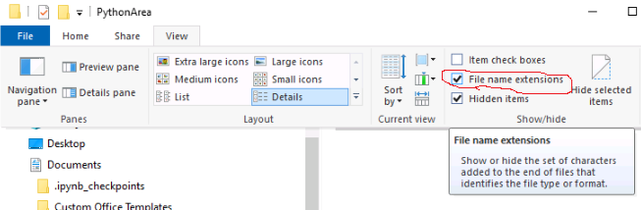

Rename the document. Ensure that it does not have a .txt extension. If the main part of the name is not already highlighted in blue, press F2 or right click on the file and select Rename. To ensure the extension is also highlighted, press ctrl-A or use your mouse. Change the name to demo.py

You will get a warning. Just click Yes.

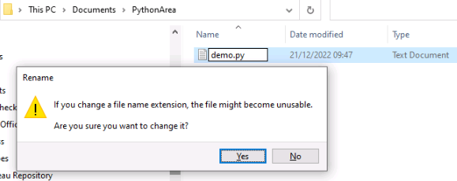

Note that you can call your Python files anything within reason, that is, any combination of letters and numbers (but don’t start with a number), but do not use spaces or punctuation marks. (You can use underscores and dashes.) In general, keep the name as simple and meaningful as possible.

Right click on your new file and select either Open with or Edit, then select Notepad++.

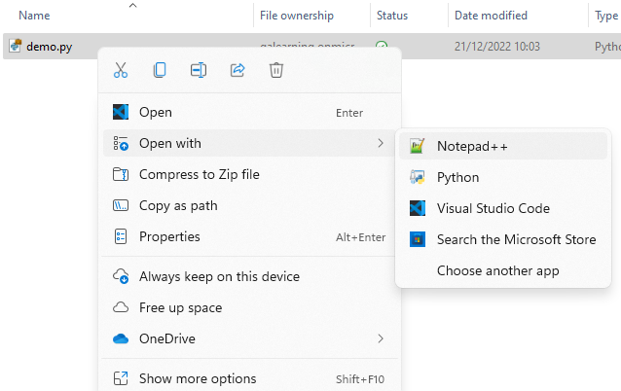

In Notepad++, type

print("Hello world!")

and save the file. (Click on File and select save, or click on the icon that looks like a floppy drive.) Note that if you have edited the file without saving, an asterisk will appear to the left of your path at the top of the editor.

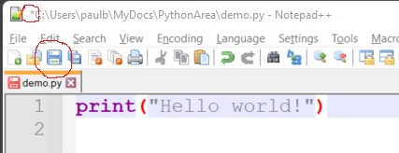

Note that your path will be different to the one above. If you have followed the instructions, yours should read

C:\Users\Admin\Documents\PythonArea\demo.py

# Command Prompt

Next we need to open a Command Prompt to run the program. You can open a Command Prompt by entering those words in the “Type here to search” field at the bottom right of the screen, and then navigate to the relevant directory using cd commands, but there is a quicker way. (Note, a directory is the same as a folder in this context. They are usually called folders when you are in File Explorer and directories when you are in Command Prompt.)

In Notepad++, right click on the tab at the top of the file you are working on. Select Open Containing Folder in cmd. This is normally about halfway down the menu, but might be located in a submenu.

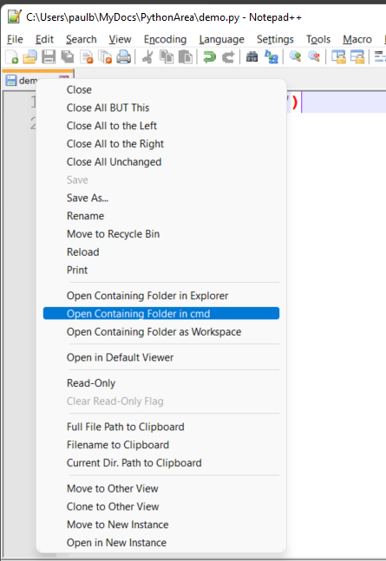

(If the menu item does not appear, look for a menu item user Save As... called Open into.)

A command prompt will appear:

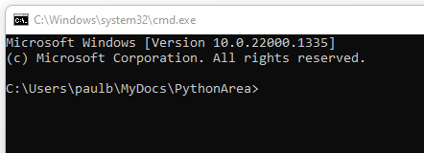

Enter

dir

to check that your Python file is present. If you do not want your path to appear as the prompt, enter

prompt $g

(Tip: To save unnecessary typing, use your up and down arrows to recall previous commands.)

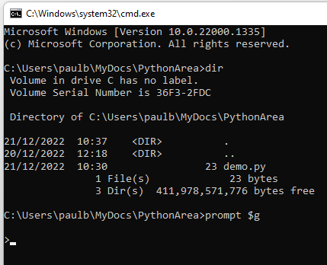

To run your file, enter the word “python” followed by a space followed by the full name of the file including the extension:

python demo.py

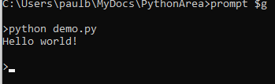

If you get the output “Hello world!” it confirms that the Python interpreter is running correctly.

# Interactive Interpreter

If you want to quickly check something in Python but don’t want to create a file, type

python

on its own in the Command Prompt. You will see a message, and the prompt will have changed to

>>>

i.e. three greater than signs. This is the Interactive Interpreter.

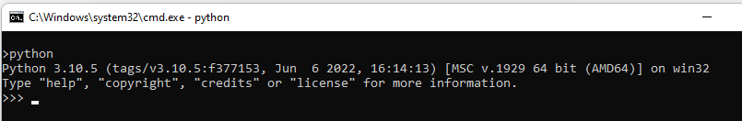

You can then enter Python script, which is run immediately. Note that you do not have to use the print function here to get the value of variables. Also, the underscore “remembers” the last thing output.

To return to the normal Command Prompt, enter

exit()

or ctrl-Z

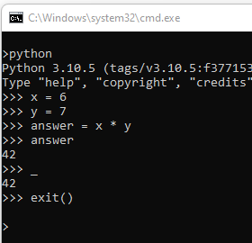

Note that if you leave the Interactive Interpreter and then go back in again, it will not remember anything from the previous session.